# CS 255 System Design Document Template

## UML Diagrams

### UML Use Case Diagram

### UML Activity Diagrams

### UML Sequence Diagram

### UML Class Diagram

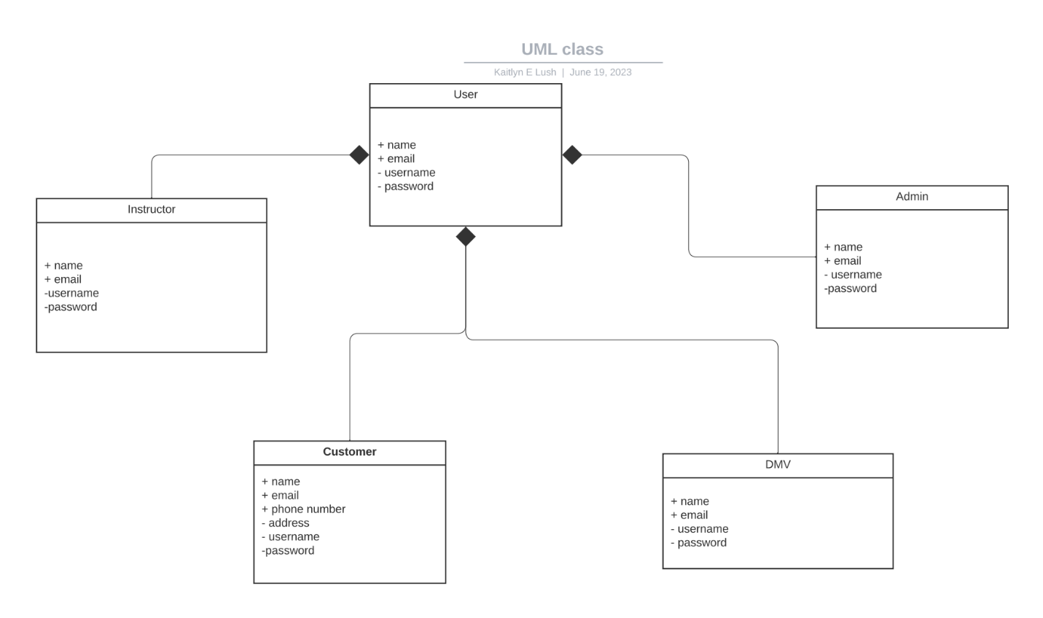

## Technical Requirements

This system will need to run on a web-based environment. It should be able to run on any platform including mobile devices. The cloud would be a good device to use for this system as it will allow for all of the storage space you would need. It will need to have a fast response time in order to compensate for the large number of users. Each user should have their own dashboard where they can take practice exams, look at reading materials, track their progress, and schedule/view their driving lessons. The system should have a secure connection and a good security system to prevent leaked information.